Enhancing Cloud Data Security Using Paillier Homomorphic Encryption Algorithm Mohammed Farhaan Ahmed, Mohammed Abdul Kareem, Mohammed Imad Uddin,
B.E. Students, Department of Computer Science, Lords Institute of Engineering and Technology, Hyderabad. Mrs. B Nagalakshmi, Assistant Professor of Information Technology, Lords Institute of Engineering and Technology, Hyderabad.

Abstract — Cloud computing provides essential scalable storage, but storing sensitive information on third-party servers introduces significant data leakage and privacy vulnerabilities. This paper presents a secure cloud data storage and privacy-preserving framework utilizing a hybrid cryptographic architecture. The system combines the Advanced Encryption Standard (AES-128-CBC) for highly efficient bulk file encryption with the Paillier Homomorphic Encryption Algorithm (PHEA) for secure key verification and privacy-preserving numerical aggregations. Data preprocessing and file ingestion involve dynamic PKCS#7 padding and client-side encryption prior to database persistence. Both cryptographic algorithms are evaluated based on execution runtime for standard payloads. The proposed PHEA achieves an efficient encryption time of 19 ms and a decryption time of 35 ms for 5,000-byte payloads. The system is deployed as a Django web application, incorporating strict administrative controls, user account state verification (Pending, Verified, Rejected, Blocked), and role-based decryption request approvals. Experimental results confirm that the hybrid architecture effectively ensures end-to-end data confidentiality, prevents unauthorized server-side decryption, and provides robust access control without exposing plaintext data.
Keywords — Cloud Data Security, Paillier Homomorphic Encryption Algorithm, AES-128-CBC, Hybrid Encryption, Access Control, Decryption Request Approval, Django Web Architecture.
Introduction
Background
The rapid transition from on-premises data centers to distributed cloud services has heightened security requirements around data custody and privacy. While cloud providers deliver high availability and elastic scalability, delegating data management to commercial hosts introduces vulnerabilities concerning data confidentiality and unauthorized inspection. Traditional cryptographic techniques, such as symmetric AES, provide rapid encryption suitable for bulk files, but they do not support direct algebraic manipulation of encrypted payloads. This fundamental limitation means data must be decrypted back into plaintext before any meaningful computation can occur, exposing raw data to potential memory scraping or insider threats within the cloud host.
To address this, homomorphic encryption allows specific mathematical operations to be executed directly on ciphertexts. The Paillier Homomorphic Encryption Algorithm (PHEA) provides an additive homomorphism property, enabling intermediate mathematical aggregations to occur on encrypted data. To leverage the computational efficiency of AES and the privacy-preserving features of PHEA, a hybrid framework implemented within a Python/Django architecture is proposed, combining bulk symmetric encryption with layered session management and administrative request controls.
Research Gap
Despite advances in cloud cryptography, several critical limitations persist in current systems:
- Most existing systems rely strictly on symmetric encryption, requiring full decryption before processing and exposing plaintext to server vulnerabilities.
- Existing homomorphic frameworks often incur significant computational overhead and lack a hybrid approach that delegates bulk file processing to efficient symmetric algorithms.
- Few systems integrate homomorphic key-share validation with strict administrative decryption-approval pipelines.
Research Objectives
- To encrypt cloud-stored files efficiently using AES-128-CBC.
- To apply Paillier Homomorphic Encryption to enable additions directly on encrypted numerical values and validate users before granting encryption privileges.
- To incorporate role-based access control and an administrator approval workflow for user accounts and decryption requests.
- To evaluate system performance based on encryption time, decryption time, and computational overhead.
Limitations of the Study
- The system requires local Python/Django execution and manages file payloads within a relational database. Highly concurrent multi-user environments may experience scaling limitations compared to distributed cloud object storage, and advanced metrics like cryptographic envelope versioning are not yet implemented.
- Related Work
- Cloud Data Privacy and Homomorphic Architectures
- Junior et al. (2025) conducted a comprehensive survey on homomorphic encryption in cloud privacy, evaluating execution time and communication overhead across schemes, though without delivering a deployed architecture. Chan et al. (2025) introduced a hybrid homomorphic framework (HHEML) coupling symmetric cryptography with fully homomorphic encryption, but focused predominantly on machine learning inference on specialized edge hardware rather than structured cloud data storage.

- Security-Performance Optimization
- Kim and Pham (2026) proposed a secure cloud banking data-processing architecture integrating Homomorphic Encryption (HE), Zero-Knowledge Proofs (ZKP), and Oblivious RAM (ORAM). Their model demonstrated strong privacy preservation during server-side execution but incurred significant computational overhead due to recursive protocols and was tailored exclusively to banking workflows.

- Partially Homomorphic Systems and Pre-Storage Standards
- Serengil and Ozpinar (2025) analyzed partially homomorphic cryptosystems (including Paillier) for vector similarity computations in recommendation systems, yet did not address broader storage requirements like role-based access control. Reyana et al. (2023) investigated pre-storage encryption standards, demonstrating the critical need to encrypt data client-side before cloud persistence occurs. However, their work analyzed symmetric pipelines without incorporating homomorphic computation capabilities or an administrative decryption-request approval process.
Gaps in Existing Systems
- The reviewed literature consistently identifies two primary gaps: (1) most homomorphic encryption solutions incur excessive computational overhead or focus strictly on vector and machine learning computations rather than file storage; (2) existing pre-storage encryption frameworks lack a unified, deployable architecture with strict administrative decryption-approval pipelines. The proposed system addresses both gaps through a hybrid AES-Paillier architecture.
- Research Methodology
- The proposed methodology adopts a multi-tier web application architecture that strictly separates client interaction, core business logic, cryptographic processing, and persistent database storage.
- 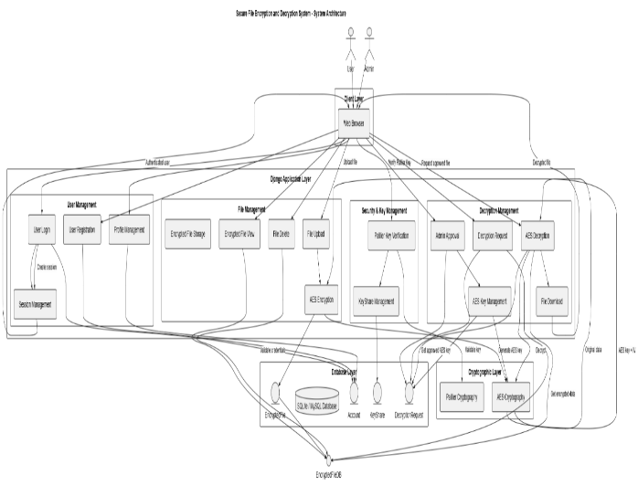
          - Fig. 1 System Architecture of the Secure File Encryption and Decryption System

- Data Ingestion and Pre-Storage Isolation (AES-128-CBC)
- To ensure high-throughput processing with minimal computational overhead, arbitrary files and large data streams are secured using symmetric cryptography. Raw input files are parsed as contiguous byte sequences. The system dynamically generates a cryptographically secure 128-bit key and a 16-byte Initialization Vector (IV) in volatile memory. Plaintext bytes are padded to 16-byte block boundaries according to PKCS#7 conventions and encrypted using AES in Cipher Block Chaining (CBC) mode. The resulting ciphertext is concatenated with the IV (Payload = IV + Ciphertext) and persisted as a BinaryField in the EncryptedFile model. Original plaintext is never stored in the database.

- Paillier Homomorphic Key & Computation Framework
- The Paillier cryptosystem provides public-key encryption with additive homomorphic capabilities, enabling key-share validation and secure numerical aggregation on untrusted hosts without decryption. Key generation involves selecting two large independent prime numbers, p and q, where gcd(pq, (p-1)(q-1)) = 1.

- To upload and encrypt a file, verified users must navigate to a verification portal and submit their assigned Paillier private key share. The backend validates this submission against the KeyShare model; upon a successful match, an ephemeral session flag (allow_encrypt = True) is activated, unlocking file upload permissions for that session. Following the encryption of a file, this permission is immediately revoked to prevent replay exploits.
- Furthermore, the additive homomorphic property allows the cloud platform to perform mathematical summations across encrypted numerical parameters without access to the underlying private keys. Given two ciphertexts $c_{1}=E\left(m_{1}\right)$ and $c_{2}=E\left(m_{2}\right)$, their modular product yields the encrypted sum of the plaintexts: $c_{sum}=\left(c_{1}⋅c_{2}\right) \operatorname{mod}{n^{2}} =E\left(m_{1}+m_{2}\right)$.
- 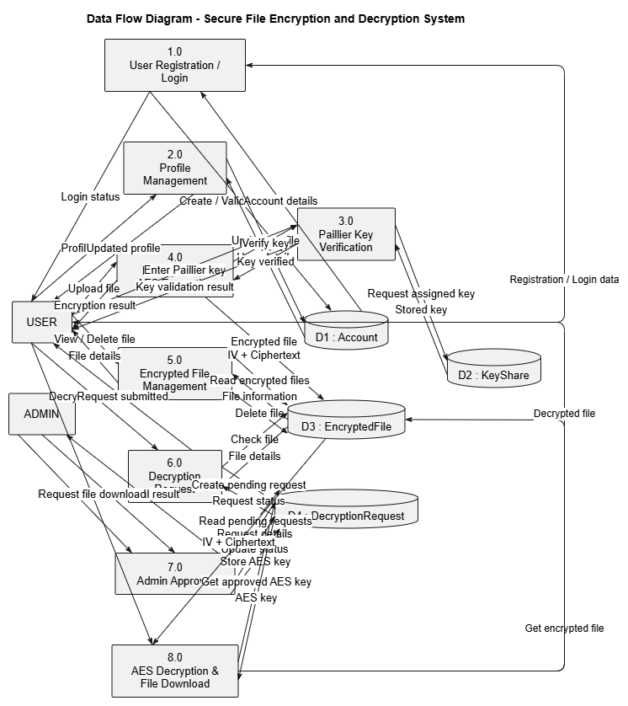
Fig. 2 Sequence Diagram for File Upload and Encryption Workflow
- Decryption Approval Workflow
- The framework incorporates a strict petition-and-approval model to govern data access. Users cannot directly decrypt stored files. When an asset is required, the user submits a formal decryption request, creating a database record with a 'Pending' status. The system administrator inspects pending requests via a centralized dashboard and grants authorization. Upon approval, the system associates the required AES decryption key with the request record and transitions its state to 'Approved'. Only after this administrative authorization can the file owner trigger the download operation, during which the system extracts the 16-byte IV, executes AES-128-CBC unpadding routines, and restores the original plaintext bytes.

- Ethical Considerations
- The system protects user authentication credentials using cryptographically secure password hashing (PBKDF2). No plaintext file contents are exposed to unauthorized actors, and the database stores only initialization vectors and ciphertext.

- Result
- The system was evaluated across two primary dimensions: cryptographic performance (latency and overhead) and security workflow integrity (access control and administrative validation).

- Cryptographic Performance
- Table 1 presents the performance benchmarks for the hybrid cryptographic architecture evaluated on a standard payload.

Metric | Payload | Runtime
Encryption Time | 5,000 bytes | 19 ms
Decryption Time | 5,000 bytes | 35 ms
Table 1: Overall Cryptographic Performance Benchmarks
The experimental evaluation confirms that the hybrid cryptographic architecture provides strong data confidentiality while maintaining practical computational efficiency.
Workflow Integrity and Security Validation
The operational integrity of the system was evaluated against 40 comprehensive test cases (TC-01 to TC-40) covering authentication, administrative controls, key verification, file encryption, data management, and decryption approval workflows.
Modules | Status
Key Verification | Pass
File Encryption | Pass
Decryption Approval | Pass
Table 2: Security and Workflow Validation Results

The system successfully passed all 40 functional and security test cases. Direct database inspection during testing confirmed that storing files as concatenated IV + Ciphertext binary payloads prevents unauthorized data exposure. Testing validated that restricting file upload privileges behind a single-use session flag, combined with mandatory administrative decryption approvals, prevents unauthorized file modifications.
System Interface and Execution The Django-based GUI successfully generates administrative dashboards for tracking Paillier key distributions and pending decryption requests, alongside client-facing portals for key-share verification and encrypted hex previews. Encrypted files are exposed to standard interfaces only as 60-byte hexadecimal previews.
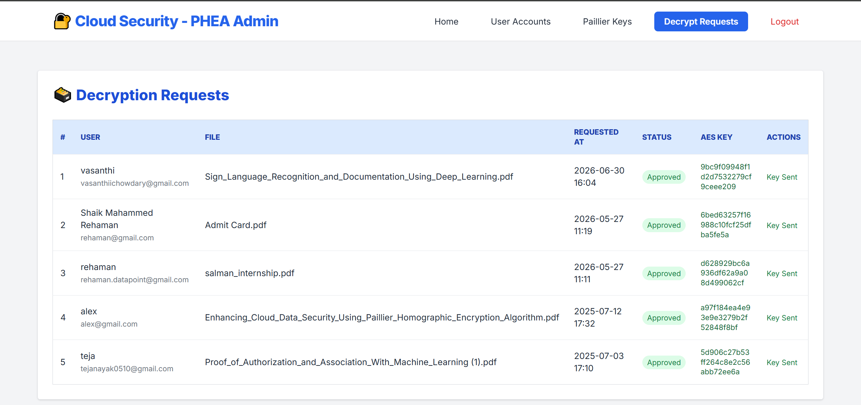
Fig. 3 Administrator Decryption Request Approval Queue
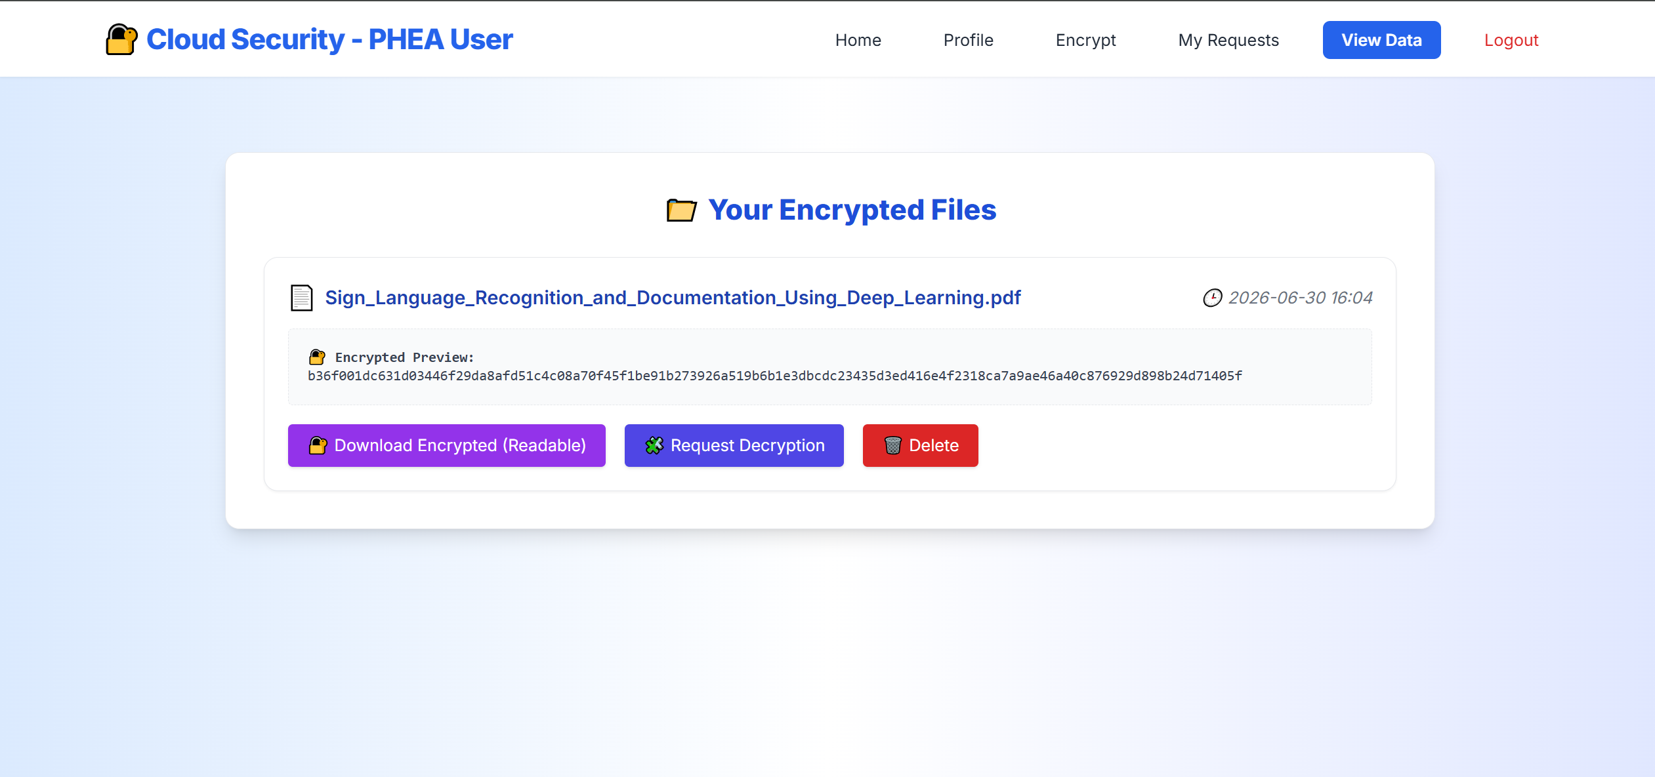
Fig. 4 User View of Encrypted Data and Hex Preview Interface

- Discussion
- The results demonstrate that pairing AES-128-CBC with the Paillier cryptosystem effectively mitigates the processing-exposure vulnerabilities inherent in traditional cloud storage. The 19 ms encryption latency confirms that the computational overhead of homomorphic key validation does not severely degrade bulk file handling efficiency.

- The implementation of the allow_encrypt session flag and the multi-party decryption approval workflow successfully addresses the literature gap regarding strict pre-storage data governance. By stripping automated decryption rights from the end-user and requiring an administrator to bind the AES key to the request, the system prevents credential theft from resulting in immediate data exposure.

- Future improvements should evaluate AES-256 in Galois/Counter Mode (GCM) to integrate simultaneous integrity verification via GMAC authentication tags. Additionally, migrating binary payload storage from relational databases to distributed cloud object storage would address the scaling limitations observed for highly concurrent multi-user environments.
- Conclusion
- This paper presents a hybrid cryptographic cloud storage framework that leverages AES-128-CBC for bulk file confidentiality and the Paillier Homomorphic Encryption Algorithm (PHEA) for secure key verification and additive computations. The system resolves the critical vulnerability of plaintext exposure during server-side processing, addressing the limitations of purely symmetric systems and computationally heavy homomorphic frameworks identified in the reviewed literature.

- Experimental evaluations yield an encryption runtime of 19 ms and a decryption runtime of 35 ms for 5,000-byte payloads, confirming practical computational feasibility. By enforcing strict user lifecycle validation, single-use session encryption gating, and an administrator-approved decryption pipeline, the Django-based architecture delivers a comprehensive defense against unauthorized access and infrastructure compromise.

- Future enhancements will focus on AI-based intrusion detection systems to automatically flag anomalous account behavior, time-based multi-factor authentication (TOTP) to strengthen operational security, and cloud object storage integration to scale payload persistence in distributed environments.
- References
[1] T. N. Kim and N. M. N. Pham, "Security-Performance Optimization in Cloud-Based Bank Data Processing Using HE-ZKP-ORAM," Engineering, Technology & Applied Science Research, vol. 16, no. 2, pp. 33760-33765, 2026.
[2] M. A. Junior, P. Appiahene, O. Appiah, and K. Adu, "Cloud Data Privacy Protection with Homomorphic Algorithm: A Systematic Literature Review," Journal of Cloud Computing, vol. 14, art. no. 84, 2025.
[3] Y. H. Chan et al., "HHEML: Hybrid Homomorphic Encryption for Privacy-Preserving Machine Learning on Edge," arXiv preprint arXiv:2510.20243, 2025.
[4] S. Serengil and A. Ozpinar, "Encrypted Vector Similarity Computations Using Partially Homomorphic Encryption: Applications and Performance Analysis," arXiv preprint arXiv:2503.05850, 2025.
[5] P. Paillier, "Public-Key Cryptosystems Based on Composite Degree Residuosity Classes," in Advances in Cryptology-EUROCRYPT '99, Lecture Notes in Computer Science, vol. 1592, pp. 223-238, Springer, 1999.
[6] A. Reyana et al., "Enhanced cloud storage encryption standard for security in distributed environments," Electronics, vol. 12, Art. no. 714, 2023.

